**Step 1:** To activate UAN, it is essential to have Universal Account Number (UAN).   
 You can get UAN on your Payslip/ Monthly PF statement

Link : *Ultimatix🡪Employee Global Servicess🡪My Documents🡪Payslip*

**Step 2:** To activate UAN go to <https://www.epfindia.gov.in>

**Step 3:** Go to **Our Services** 🡪 **For Employees (screen below)**.

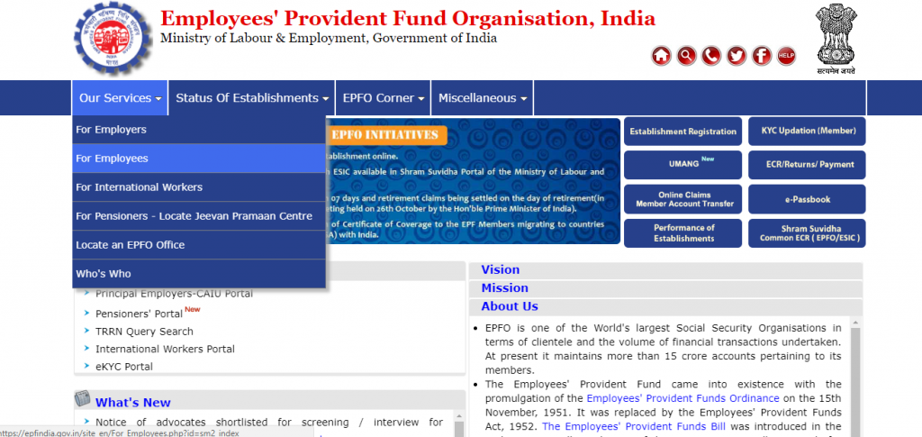

Click Here

**Step 4:** Under **Services**, click **Member UAN/Online Services (OCS/OTCP)**. UAN portal page appears. (Screen below)

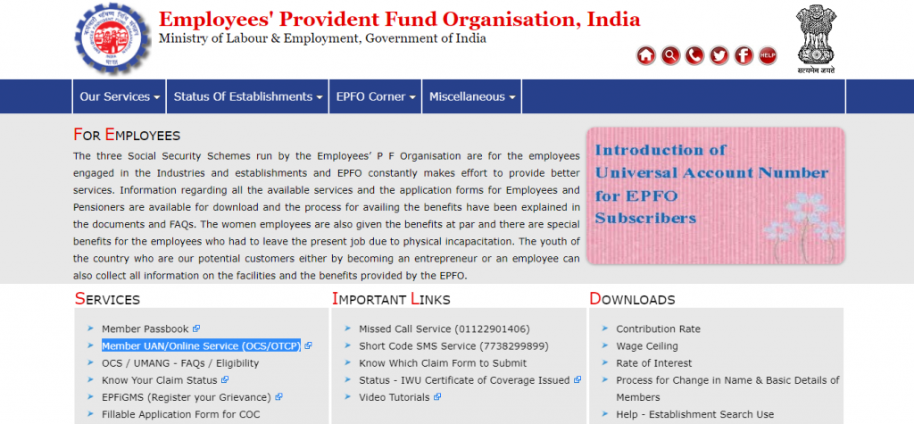

Click Here

**Step 5:** Click on Activate UAN (Screen below)

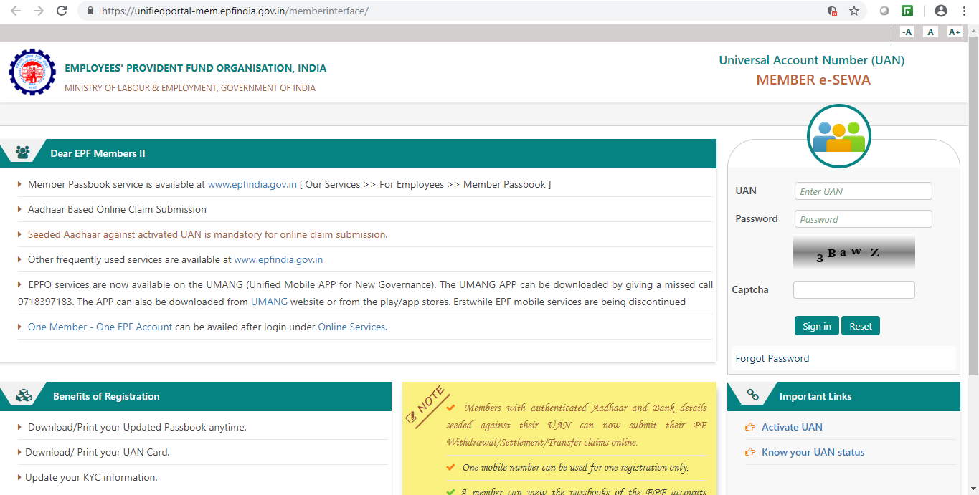

Click Here

**Step 6:** Provide your **UAN**, **Name**, **Date of Birth** and **Mobile No.**

**Step 7:** Provide the **Captcha** characters.

**Step 8: C**lick **Get Authorization Pin**. You will receive the PIN on registered mobile number, which you have registered, with Aadhaar. (Screen below).

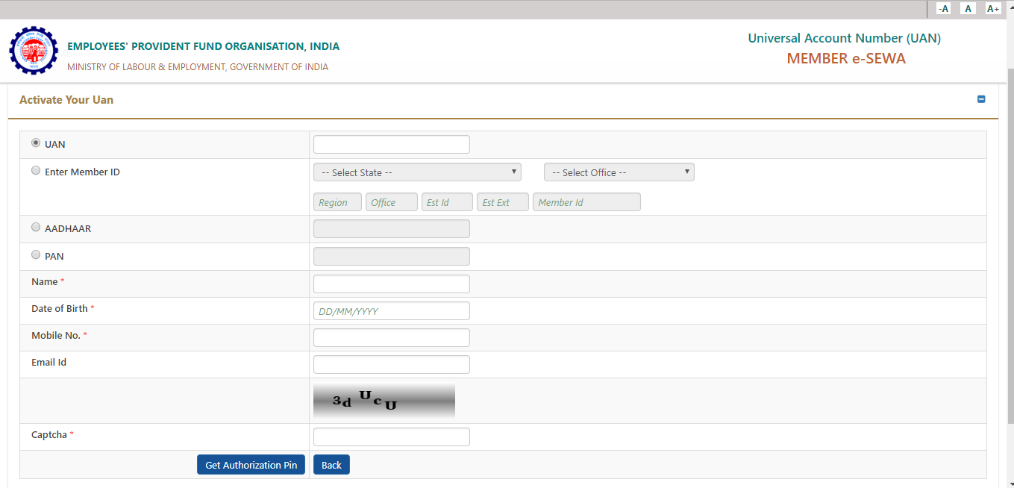

Enter UAN: Please Search UAN on Payslip / PF statement

Step 8: Select **I Agree** and provide the OTP that received on mobile number. Click **Validate OTP and Activate UAN**. (Screen below)

~~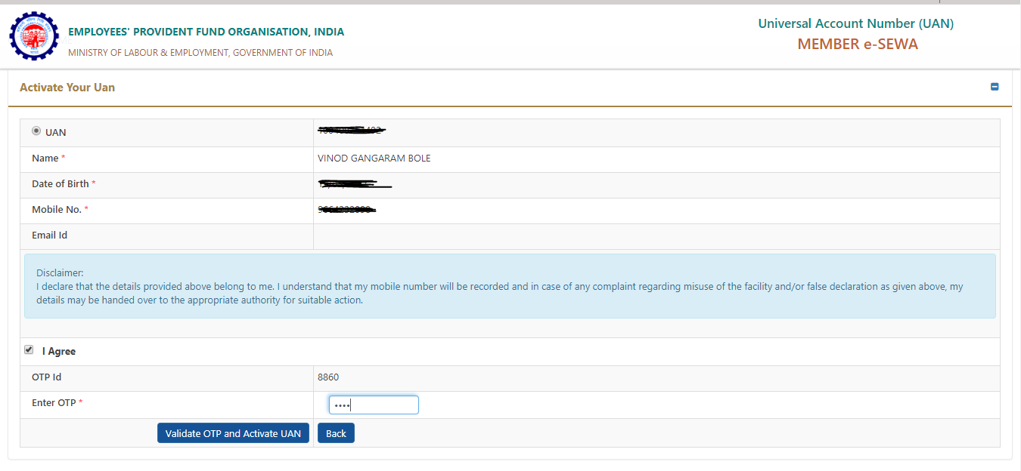~~

Enter OTP received on your mobile number

**Step 9:** On activation of the UAN, UAN login **password** will be sent on your registered **mobile** number to access your account.

**Step 10:** Login to the UAN portal with UAN number & password (received on mobile) and change the password to the account.